Mount Si High School Cheerleading
2021-2022
TRYOUT PACKET

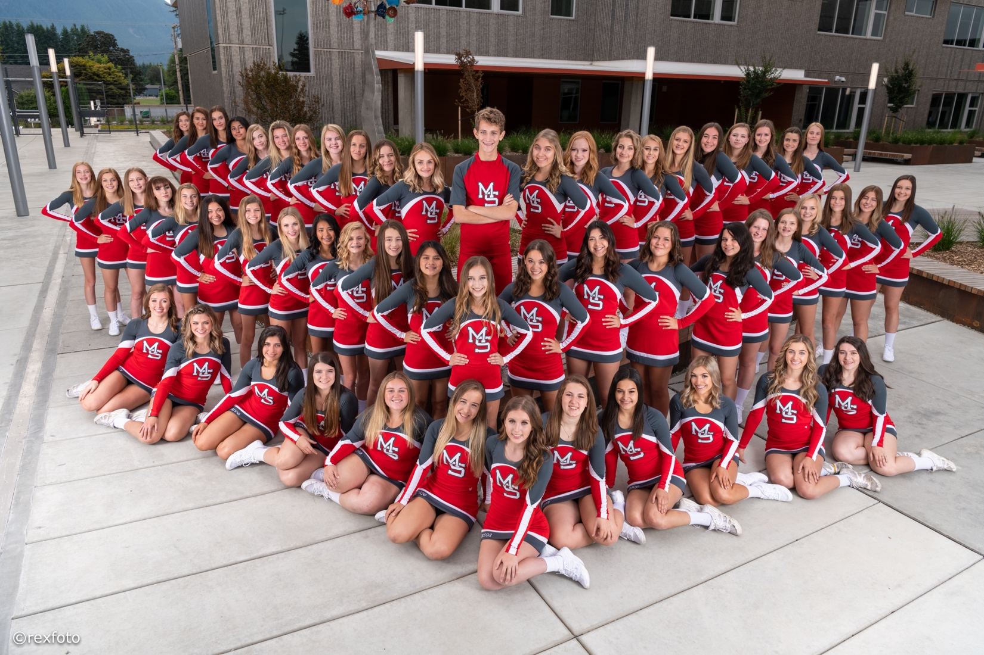

Mount Si Fight Song
Fight, fight, fight for old Mount Si High
Win a victory
Come on and win this day for Scarlet and Gray
Best in the West, we know you’ll all do your best.
So on, on, on, on, on 'till the end.
Honor and glory we shall see.
So fight, fight, fight for old Mount Si High
and Victory

MOUNT SI HIGH SCHOOL CHEERLEADING
VARSITY and JUNIOR VARSITY FOOTBALL and BASKETBALL SIDELINE
and COMPETITION SQUAD(S)

Dear Parents and Students:

Cheerleading is a very important part of Mount Si High School. Holding this job is a big responsibility. Being a Cheerleader is hard work, and requires constant dedication to self, squad/team, school, and the community.

Cheerleaders should ask themselves, “Why do I want to be a cheerleader?” Individuals should remember that as part of the cheerleading team, they are a representative of MSHS, and are expected to display a positive leadership image at all times. The most important element of high school is a student’s academic progress. Therefore, cheer squad members are required to have a 2.0 cumulative GPA and be passing all classes– No F’s. In addition, Mount Si Cheerleaders are held to Mount Si’s Athletic Code in regards to Drug/Tabaco/Alcohol use.

There is a huge time commitment involved in being a cheerleader. Some of the many commitments are: fundraisers, camp, summer practices, and many hours during and after school. Cheer commitment comes before other activities! Candidates should understand that only illness and special family circumstances are legitimate reasons to miss a cheer activity. Many times practices go longer than planned or the squad is asked to perform at an unscheduled event. This is why it is important to be able and willing to go the extra mile. Cheer Squad members are required to attend all scheduled practices, meetings and performances in their entirety.

A tentative schedule for May through August is provided in this packet. After teams are selected and numbers finalized, an updated calendar will be released. Any conflicts should be addressed with the coach immediately. Some dates will be deleted and some added depending on squad readiness, conflicting school performances, and athletic schedules. In the Spring, all cheerleaders will practice approximately 6 hrs/week in addition to some community service. August will be busy with practices to prepare for Football season and parades. In the Fall and Winter, Cheerleaders will practice approx. 5-8 hrs/week (depending on their team placement) plus games and Saturday competitions (once again dependent upon team placement). Competition season runs from November through January. We will attend approximately five Saturday competitions. Nationals is in February of 2022.

Cheerleading is expensive (approx. $1500-$3000 per cheerleader depending on JV/Varsity and Returner/New Cheerleader and Nationals team members). This will be explained at the parent/cheer candidate meeting on determined date. Many fundraising opportunities will also be available as organized by the MSHS Cheer Booster Club.

Being a part of Mount Si Cheer can be some of the best memories and times of your life. Cheerleaders will get to know each other in such a way that it cannot be compared to that of any other team. We wish all of you the best at tryouts; enjoy the experience and GOOD LUCK TO YOU!

Tori Kirk, Robby Sortore, Jessii Stevens, Christa Fitzpatrick
Mount Si High School Competition and Sideline Cheer Coaches
victoriakirk11@yahoo.com

TRYOUT SCHEDULE AND DATES TO REMEMBER

Tryout Clinic (Mandatory)
Location: Aux Gym
The aux gym can be found on the second level within the high school. Enter through the back of the school by the football field. There will be a staircase to take you upstairs, then the gym is located to your right.
Dates: May 11th and May 12th
Times: 4 pm -6 pm
Please fill out ATTESTION every day upon arrival!
https://svsd410.qualtrics.com/jfe/form/SV_eQld8vPJHxpJZUW

Tryout
Location: Aux gym
Date: May 14th
Time: Everyone arrives at 4:30. The first group will go at 4:45. You will tryout in groups of 4.
Please fill out ATTESTION every day upon arrival!
https://svsd410.qualtrics.com/jfe/form/SV_eQld8vPJHxpJZUW

Parent Meeting
Location: TBD; hopefully in person but if not via Zoom
Date: May 25th
Time: TBD

Uniform Fitting
Location: Virtual
Date: May 26th
Time: 4 pm

Practices
Dates: Week of may 18th – June 17th
Day: Tues/Thurs
Time: 4-6 pm
Location: Aux gym

TRYOUT RULES AND EXPECTATIONS

- Attendance
  - You must be fully dressed and in the aux gym on time for all Tryout Material Clinics. On Friday, May 14th, we will start reviewing material at 4:30 p.m. The first tryout group will go at 4:45 p.m.
  - Communication is key. If you are running late or have to miss clinic for any reason, you need to communicate with Coach Tori ahead of time. It is your responsibility to learn any missed material.

- Clothes and Attitude
  - Wear a MSHS colored shirt (red, grey, black or white), black shorts and athletic shoes for all tryout clinics. Please also wear a face covering anytime on campus. For actual tryouts, you and your group should wear similar colored shirts and shorts in MSHS colors (ex. grey shirts and black shorts). You DO NOT need to purchase anything special for tryouts unless you choose to. You WILL NOT be judged on your outfit.
    - You WILL be judged on presentation of yourself. Therefore you should be nicely groomed, clothes without holes, etc. for tryouts.
  - Put your hair up for practice and tryouts.
  - Absolutely no jewelry. NEW PIERCINGS WILL BE EXPECTED TO BE REMOVED DURING ANY AND ALL PRACTICES, NO EXCEPTIONS.
  - Please be respectful to others and have a positive attitude. Ask questions!
  - Cell phones should be turned off or silent.

- Paperwork
  - Complete Mount Si’s online athlete registration found at: https://www.familyid.com/mount-si-high-school
    - This MUST be completed by Tuesday May 11th to be eligible to tryout
  - Fill out and turn in the Tryout Information Sheet at your first day of clinics
    - Due Tuesday May 11th
  - The office will complete a grade check for current classes. You must have a 2.0 cumulative GPA and be passing all of your classes to tryout and be an active member of the squad. No F’s!
  - It is your responsibility to ensure all paperwork is complete and submitted before the deadline.
  - All athletes must fill out an attestation for everyday they are on campus. Please follow the link below and provide a screenshot when you arrive on campus to show a coach.
- https://svsd410.qualtrics.com/jfe/form/SV_eQld8vPJHxpJZUW

- Tryouts
  - You must be a current 8th grader, Freshman, Sophomore, or Junior and enrolled at Mount Si to be eligible to tryout.
  - You must be in good physical health.
  - You must have satisfactory school attendance.
  - You will tryout in groups of 4
  - Perform tumbling (if applicable), Tryout Cheers, Dance and Jumps.
  - You will be judged during tryouts on the following categories: Tryout Cheers, Tryout Dance, Jumps, Tumbling and Overall Impression. Some important things the judges will consider are: facial expression, eye contact, confidence, enthusiasm, technique, sharpness of moves, motion placement and voice.
  - You will tryout only in front of the judges and tryout staff. It will not be in front of the student body. No parents or friends will be allowed to watch the tryouts or try-out clinics.
  - The score will be calculated from judges’ scores. The number of cheerleaders chosen for each squad will be determined by score separation.
  - You will find out if you made the squad approximately 45-60 minutes after the last group finishes trying out.

- Teams
  - Two teams will be announced – Varsity Sideline and JV Sideline. There is no set number of cheerleaders chosen for either squad.
    - A Varsity Sideline Cheerleader will cheer for:
        - All Home Varsity Football (approx. 5 games)
        - Split Away Varsity Football (approx. 4 games, cheer for 2-3)
        - Share Friday Night Home Basketball
    - A JV Sideline Cheerleader will cheer for:
        - JV Home Football (potentially one Away JV Game depending on schedule)
        - Weekday Home Basketball (typically Tuesday and Wednesday)
    - Mount Si’s Competition Team(s) will be chosen by June. Varsity and JV Sideline placements have NO BEARING on Competition Squad placements.
        - Mount Si’s RED competition team will attend Masters Camp Dates TBD .

TRYOUT INFORMATION SHEET – Please print neatly. If we cannot read your email address, you may miss out on important emails!

Cheerleader Name: ____________________________ Cheerleader Email: __________________________

Cheerleader Cell: ______________________________ Current Grade: ___________

Parent(s) Name(s): _____________________________________________________

Parent Email #1: __________________________ Parent Email #2 (optional): ________________________

Parent Cell #1: ____________________________ Parent Cell #2 (optional): _________________________

Cheer/Dance/Gym Experience:
Where? _________________________ # of years? __________

Where? _________________________ # of years? __________

Where? _________________________ # of years? __________

Tumbling – check all that you can throw WITHOUT spot:

Standing BHS ____ Standing Tuck ____

Running BHS ____ Running BHS Series ____ Running Tuck ____ Running Layout/Full ____

Please remember that Sideline placements have no bearing on Mount Si’s Competition Team(s) placements. I am trying out for the following Sideline Team:

____ Varsity Sideline. If I do not make the Varsity Sideline cut-off for tryout scores, I DO NOT want to participate on Mount Si Cheer.

____ I would prefer a position on JV Sideline.

____ I would accept a position on Varsity or JV Sideline.

I have read the Tryout Rules and Expectations and have contacted the coach(es) with any questions or concerns I may have. I understand that there is a mandatory Parent/Cheerleader Meeting and Team Dinner TBD.

___________________________________ _____________________________________
Tryout Candidate Signature Parent Signature

FREQUENTLY ASKED QUESTION

- What does the cost cover?
  - The cost varies greatly depending on which squad you are on as well as if you are a returning or new cheerleader. In the welcome letter on pg. 2, you will see that cost ranges from approx. $1500-$3500. A new cheerleader who is chosen for our Nationals team will be in the upper range, whereas a returning Sideline JV cheerleader will be in the lower range. Depending on the team you are on, your cost will cover: uniform, campwear, warm-ups, poms, bows, 3-4 day cheer camp, specialty t-shirts for different events, choreography, competition fees, competition music, banquet/team event food, birthday treats, treats for opposing cheerleaders, assistant coaches stipend, and Nationals trip (airfare, hotel, registration, transportation, 2 meals, Nationals wear).
  - A more accurate cost will be presented at the meeting on May 7th.
  - New uniforms are purchased after three seasons. This season will start our 3rd year with these uniforms.

- What if I want to go on vacation in August?
  - August is a busy month. We take August to prepare for parades, football season, assemblies, and competition season. Missing one or two practices in August is manageable; missing a week of practices in August is not.

- What if I don’t like cheer after a month or so?
  - If need be, you can dismiss yourself from the squad. Most costs will be non-refundable including uniforms, campwear, warm-ups, camp cost, coaches stipend, etc. Meaning, you are still responsible for any balance you have acquired if you quit! Please understand that cheer is a team sport and your actions and commitment will have an impact on others. Unlike other sports, we don’t have a back-up quarterback or a second string of players! Everyone has an unique job to do and quitting will impact many people and will be cause valuable loss of time to your team as we will have to rearrange routines, spots, game day material due to you leaving.

- What is the policy for Alcohol and Drug use?
  - Mount Si Cheer abides by the Mount Si High School Athletic Handbook with Athletic Code for Alcohol, Tabaco and Drug violations. This handbook can be found at: http://www.svsd410.org/Page/6634

- I have no experience. Should I still tryout?
  - YES! We can find a spot for anyone with a great attitude and a work ethic. Material might not come as easily for you but some of our best Sideline Cheerleaders have been girls who came into the program with no experience. After a season or two in the program, they are completely changed athletes!

May | 2021
Sunday | Monday | Tuesday | Wednesday | Thursday | Friday | Saturday
 |  |  |  |  |  | 1
2 | 3 | 4 | 5 | 6 | 7 | 8
9 | 10 | 11 | 12 | 13 | 14 | 15
 |  | TRYOUT CLINIC 4-6 | TRYOUT CLINIC 4-6 |  | TRYOUTS  4:30
16 | 17 | 18 | 19 | 20 | 21 | 22
 |  | 1st Practice  4-6 |  | Practice 4-6
23 | 24 | 25 | 26 | 27 | 28 | 29
 |  | Practice 4-6  ParentMeeting | Uniform Fitting @ 4 | Practice 4-6
30 | 31

June | 2021
Sunday | Monday | Tuesday | Wednesday | Thursday | Friday | Saturday
 |  | 1 | 2 | 3 | 4 | 5
 |  | Practice 4-6 |  | Practice 4-6
6 | 7 | 8 | 9 | 10 | 11 | 12
 |  | Practice 4-6 |  | Practice 4-6
13 | 14 | 15 | 16 | 17 | 18 | 19
 |  | Practice 4-6 |  | Last Practice 4-6
20 | 21 | 22 | 23 | 24 | 25 | 26
27 | 28 | 29 | 30

Summer Break
Your summer break will start on June 18th this season. NO PRACTICES from June 18- July 31.

August | 2021
Sunday | Monday | Tuesday | Wednesday | Thursday | Friday | Saturday
1 | 2 | 3 | 4 | 5 | 6 | 7
 | Practice  Time: TBD | Practice | Practice | Practice
8 | 9 | 10 | 11 | 12 | 13 | 14
 | Practice | RED/JV - UCA CAMP | RED/JV - UCA CAMP | RED/JV - UCA CAMP | RED/JV - UCA CAMP
15 | 16 | 17 | 18 | 19 | 20 | 21
 | Practice | Practice | Practice | Practice
22 | 23 | 24 | 25 | 26 | 27 | 28
 | Practice | Practice | Practice
29 | 30 | 31
Practice time is TBD, will be announced by JUNE.
I am waiting on the football schedule along with potential parades for this year to add to the calendar.

